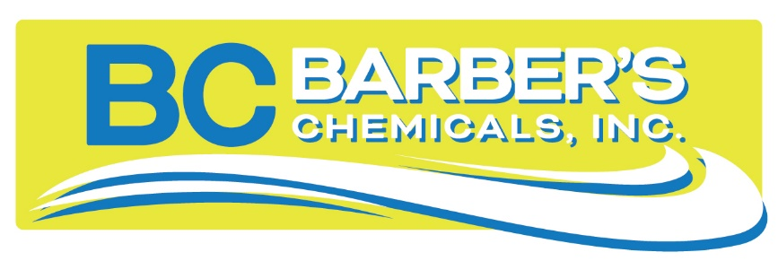
Swimming Pool Pesticide Applicators Courses being offered in your area!
All required pesticide core credits (6) and category 24 swimming pool credits (4) for recertification with the PA Department of Agriculture.
Pennsylvania Category 24 Pesticide Applicators Course
[Type a quote from the document or the summary of an interesting point. You can position the text box anywhere in the document. Use the Drawing Tools tab to change the formatting of the pull quote text box.]

Our one day class presents information needed to understand the core pesticide and category 24 pool requirements. This class teaches general pesticide handling and safety recommendations as well as teaching the basics of effective pool and spa operation. It is a primer for the state licensing test.

A resource book for both core and category 24 materials is provided for anyone who is not yet licensed. The test for your Pesticide Applicator license should be scheduled with the PA Department of Agriculture at a later date and is not included in the price of this course.

The cost for this class is $145.

April 25, 2024 May 10, 2024 September 13, 2024
Eastside YMCA Buhl Park Casino Buhl Park Casino
2101 Nagle Rd. 715 Hazen Rd 715 Hazen Rd
Erie, PA 16510 Hermitage, PA 16148 Hermitage, PA 16148

Registration Form

Last Name___________________________
First Name___________________________
Business Name________________________
Business Address______________________
City_________________________________
State, Zip Code________________________
Business Phone_______________________
Email ________________________

Please register as soon as possible to secure your seat in the class by calling Bobbie at
724-962-7886. You can also e-mail your registration to bobbie@barbchem.com Registrations and payment must be received and approved at least 4 days prior to the class.

